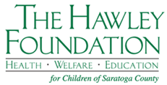

The Hawley Foundation for Children
Request for Discretionary Funds Checklist

To request funds, a social worker, service coordinator, case manager, physician, school nurse, therapist, teacher, counselor, etc. must submit a written request on letterhead that describes the need(s) of the child.

Please include:

- Name and age of child(ren)
- Amount requested
- Purpose of funds

Please provide the following which will be needed if your request is approved.

- To whom the check should be made payable
- Name and address to send check

All information shall remain confidential.

Send to:

The Hawley Foundation for Children
Discretionary Request
P.O. Box 1017
Saratoga Springs, NY 12866

