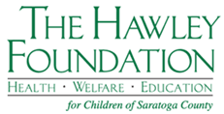

The Hawley Foundation for Children Charitable Giving

Please fill out the following form and mail form with your check to:

The Hawley Foundation for Children
P.O. Box 1017
Saratoga Springs, NY 12866

All gifts are acknowledged by us and may be tax-deductible in accordance with the Internal Revenue Code. Please review all aspects of a gift with a tax advisor.

***************************************************************************

I would like to make a contribution in the amount of $ ________________________ to
The Hawley Foundation for Children.

Name: ________________________________________________________________________

Address: ______________________________________________________________________

______________________________________________________________________

City: _________________________________ State: ___________ Zip: __________________

Email: ________________________________________________________________________

Phone: _______________________________________________________________________

